SQL-Assignment-4

Name: PATEL DEV V.

1.Create a stored procedure in the Northwind database that will calculate the average value of Freight for a specified customer.Then, a business rule will be added that will be triggered before every Update and Insert command in the Orders controller,and will use the stored procedure to verify that the Freight does not exceed the average freight. If it does, a message will be displayed and the command will be cancelled

QUERY:

DROP PROCEDURE IF EXISTS spAvgFreightForCustomer
create procedure spAvgFreightForCustomer
@customer_id char(5),
@AvgFreight real output
as
begin
select @AvgFreight = avg(freight)
from orders
where CustomerID = @customer_id;
end

Declare @AvgFreight real
EXECUTE spAvgFreightForCustomer 'ROMEY', @AvgFreight = @AvgFreight OUTPUT
select @AvgFreight as [answer];

alter TRIGGER trCheckAvgVal
ON orders
FOR INSERT, UPDATE
AS
BEGIN
DECLARE @AverageFreightValue real, @InsertedFreight real, @OldAverage real
DECLARE @CustomerId char(5), @Count int
DECLARE @errorText NVARCHAR(100)
SELECT @CustomerId = CustomerID, @InsertedFreight = freight FROM inserted

DECLARE @DeletedId int, @OldFreight real
SELECT @DeletedId = OrderID, @OldFreight = freight FROM deleted

SELECT @Count = COUNT(OrderID) FROM orders WHERE CustomerID = @CustomerId

EXECUTE spAvgFreightForCustomer @CustomerId , @AvgFreight = @AverageFreightValue OUTPUT

If @DeletedId IS NULL
BEGIN
SET @OldAverage = ((@AverageFreightValue * @Count) - @InsertedFreight)/(@Count-1)
END
ELSE
BEGIN
SET @OldAverage ((@AverageFreightValue*@Count - @InsertedFreight+@OldFreight)/ (@Count)
END

IF @InsertedFreight > @OldAverage
BEGIN
SET @errorText = 'Frieght Value cannot be greater than Average Fright value = '+CAST(@OldAverage AS NVARCHAR)
RAISERROR(@errorText,16,1)
ROLLBACK TRAN
END
END

insert into Orders (EmployeeID,OrderDate,Freight,ShipCity,ShipCountry)
values( 1, '1998-05-06',200,'Albuquerque','USA’)

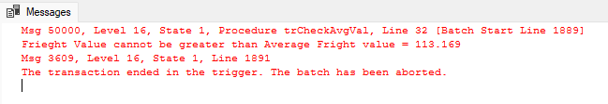

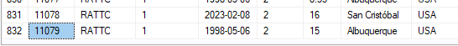

2. write a SQL query to Create Stored procedure in the Northwind database to retrieve Employee Sales by Country

QUERY:

CREATE PROCEDURE spRetrieveEmployeeSalesByCountry
@ShipCountry NVARCHAR(15),
@EmployeeID INT

AS

BEGIN

SELECT O.ShipCountry AS "Country",COUNT(E.EmployeeID) AS "Total Sale Items" , SUM(OD.Quantity *(1-OD.Discount)* OD.UnitPrice) AS "Total sales amount"
FROM Orders O INNER JOIN Employees E ON O.EmployeeID = E.EmployeeID
INNER JOIN [Order Details] OD ON O.OrderID = OD.OrderID
WHERE ShipCountry = @ShipCountry AND E.EmployeeID = @EmployeeID
GROUP BY ShipCountry

END

EXECUTE spRetrieveEmployeeSalesByCountry USA, 3

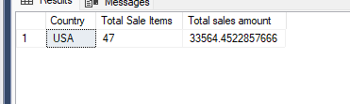

3. write a SQL query to Create Stored procedure in the Northwind database to retrieve Sales by Year

QUERY:

CREATE PROCEDURE spRetrieveSalesByYear
@Year NVARCHAR(60)

AS

BEGIN

SELECT YEAR(O.ShippedDate) AS "Year", COUNT (YEAR(O.ShippedDate)) AS "Total Sale Items", SUM(OD.Quantity *(1-OD.Discount)* OD.UnitPrice) AS "Total sales amount"
FROM Orders O INNER JOIN Employees E ON O.EmployeeID = E.EmployeeID
INNER JOIN [Order Details] OD ON O.OrderID = OD.OrderID
WHERE YEAR(O.ShippedDate) = YEAR(@Year)
GROUP BY YEAR(O.ShippedDate)
END

EXECUTE spRetrieveSalesByYear 1996

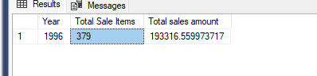

4. write a SQL query to Create Stored procedure in the Northwind database to retrieve Sales By Category

QUERY:

CREATE PROCEDURE spRetrieveSalesByCategories
@CategoryName VARCHAR(15)

AS

BEGIN

SELECT C.CategoryName, COUNT(C.CategoryName) AS "Total Sale items" , SUM(OD.Quantity *(1-OD.Discount)* OD.UnitPrice) AS "Total sales amount"
FROM [Order Details] OD INNER JOIN Orders O ON OD.OrderID = O.OrderID
INNER JOIN Products P ON OD.ProductID = P.ProductID
INNER JOIN Categories C ON P.CategoryID= C.CategoryID
WHERE C.CategoryName = @CategoryName
group by C.CategoryName
order by C.CategoryName ASC

END

EXECUTE spRetrieveSalesByCategories 'Confections'

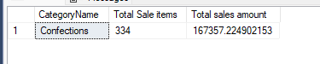

5. write a SQL query to Create Stored procedure in the Northwind database to retrieve Ten Most Expensive Products

QUERY:

CREATE PROCEDURE spTenMostExpensiveProduct

AS

BEGIN

SELECT TOP 10 *
FROM Products
ORDER BY UnitPrice DESC

END

EXECUTE spTenMostExpensiveProduct

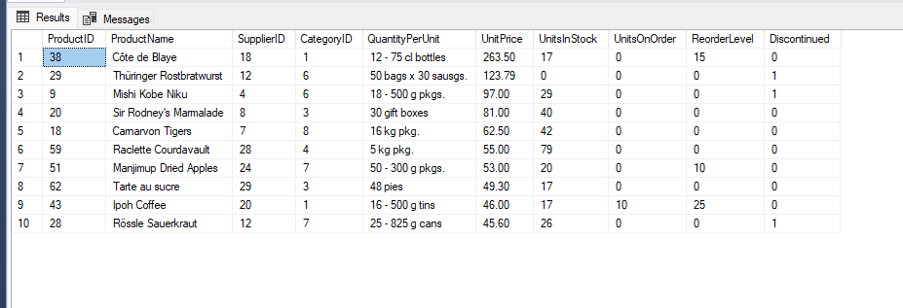

6. write a SQL query to Create Stored procedure in the Northwind database to insert Customer Order Details

QUERY:

CREATE procedure spInsertCustomerOrderDetails

@CustomerId char(5), @EmployeeId int, @ShipVia int , @FreightVal real,@ShipCity nvarchar(15) , @ShipCountry nvarchar(15) , @product_id int , @quantity int , @discount real

as
begin

declare @order_id int , @unit_price real
set @order_id = (select max(OrderID) from orders)+1
set @unit_price = (select UnitPrice from products where ProductID = @product_id)

begin try

insert into orders (OrderID,CustomerID,EmployeeID,ShippedDate
,ShipVia,Freight,ShipCity,ShipCountry)
values (@order_id , @CustomerId , @EmployeeId,GETDATE(), @ShipVia, @FreightVal,
@ShipCity, @ShipCountry)

insert into [Order Details] values (@order_id , @product_id , @unit_price , @quantity , @discount)

end try

begin catch
RAISERROR ('ERROR OCCURS',16,1)
ROLLBACK TRAN

end catch

end

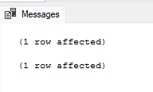

7. write a SQL query to Create Stored procedure in the Northwind database to update Customer Order Detail

QUERY:

CREATE PROCEDURE spUpdateCustomerOrderDetails
@OrderId int, @CustomerId char(5), @EmployeeId int, @OrderDate date,
@ShipVia int ,@Freight real, @ShipCountry nvarchar(15),
@ProductId int, @Quantity int, @Discount real , @ShipCity nvarchar(15)
AS
BEGIN
DECLARE @UnitPrice real
BEGIN TRAN
set @UnitPrice = (select UnitPrice from products where ProductID = @ProductId)

BEGIN TRY
UPDATE orders
SET
CustomerID = @CustomerId, EmployeeID = @EmployeeId, OrderDate = @OrderDate, ShipVia = @ShipVia, freight = @Freight, ShipCity = @ShipCity, ShipCountry = @ShipCountry WHERE OrderID = @OrderId

UPDATE [Order Details]
SET @ProductId = @ProductId, UnitPrice = @UnitPrice, quantity = @Quantity, discount = @Discount WHERE OrderID = @OrderId

COMMIT TRAN
END TRY
BEGIN CATCH
SELECT ERROR_MESSAGE() as Error
ROLLBACK TRAN
END CATCH
END

